**To use bootstrap in any project**

1. Open powershell in your project folder
2. Use **npm install**
3. If you don’t have **package.json** file get it in your project folder (check if it is configured that is it has **server lite settings**)
4. Open your project folder in your editor and create a **.gitignore** file and write **node_modules** there
5. Then initialize git using **git init**
6. After that use **git add .**
7. After that use **git commit** to commit all the files
8. After that you can synchronise your local repository to online repository
9. Now to fetch bootstrap use **npm install** [**bootstrap@4.0.0**](mailto:bootstrap@4.0.0) **-- save**
10. After that install jquery and popper.js for that use **npm install** [**jquery@3.3.1**](mailto:jquery@3.3.1)[**popper.js@1.12.9**](mailto:popper.js@1.12.9) **--save**
11. To check if bootstrap in fetch properly go to node modyles and see if there is bootstrap folder
12. After that start the lite server using npm start
13. After this add **code snippet** in the source code of your project in the <head> tag

**This is done to include css and js classes provided by the bootstrap into our project in href we have given link to a bootstrap.min.css folder it contains those classes**

<!-- Required meta tags always come first -->

    <meta charset="utf-8">

    <meta name="viewport" content="width=device-width, initial-scale=1, shrink-to-fit=no">

    <meta http-equiv="x-ua-compatible" content="ie=edge">

    <!-- Bootstrap CSS -->

    <link rel="stylesheet" href="node_modules/bootstrap/dist/css/bootstrap.min.css">

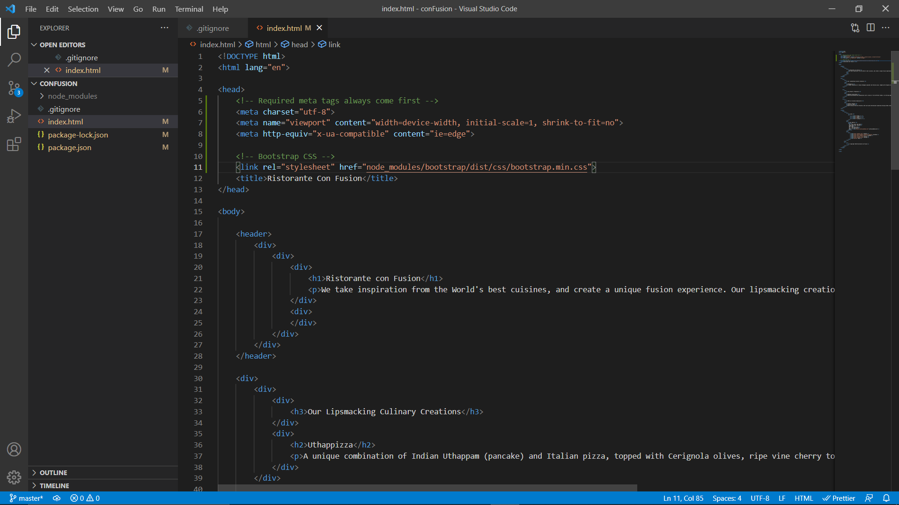

1. After this we will include all the scripts these 3 lines will include jquery & popper.js and bootstrap min.js always include them in the same order and always include it to the bottom of the page where body tag closes

 <!-- jQuery first, then Popper.js, then Bootstrap JS. -->

    <script src="node_modules/jquery/dist/jquery.slim.min.js"></script>

    <script src="node_modules/popper.js/dist/umd/popper.min.js"></script>

    <script src="node_modules/bootstrap/dist/js/bootstrap.min.js"></script>

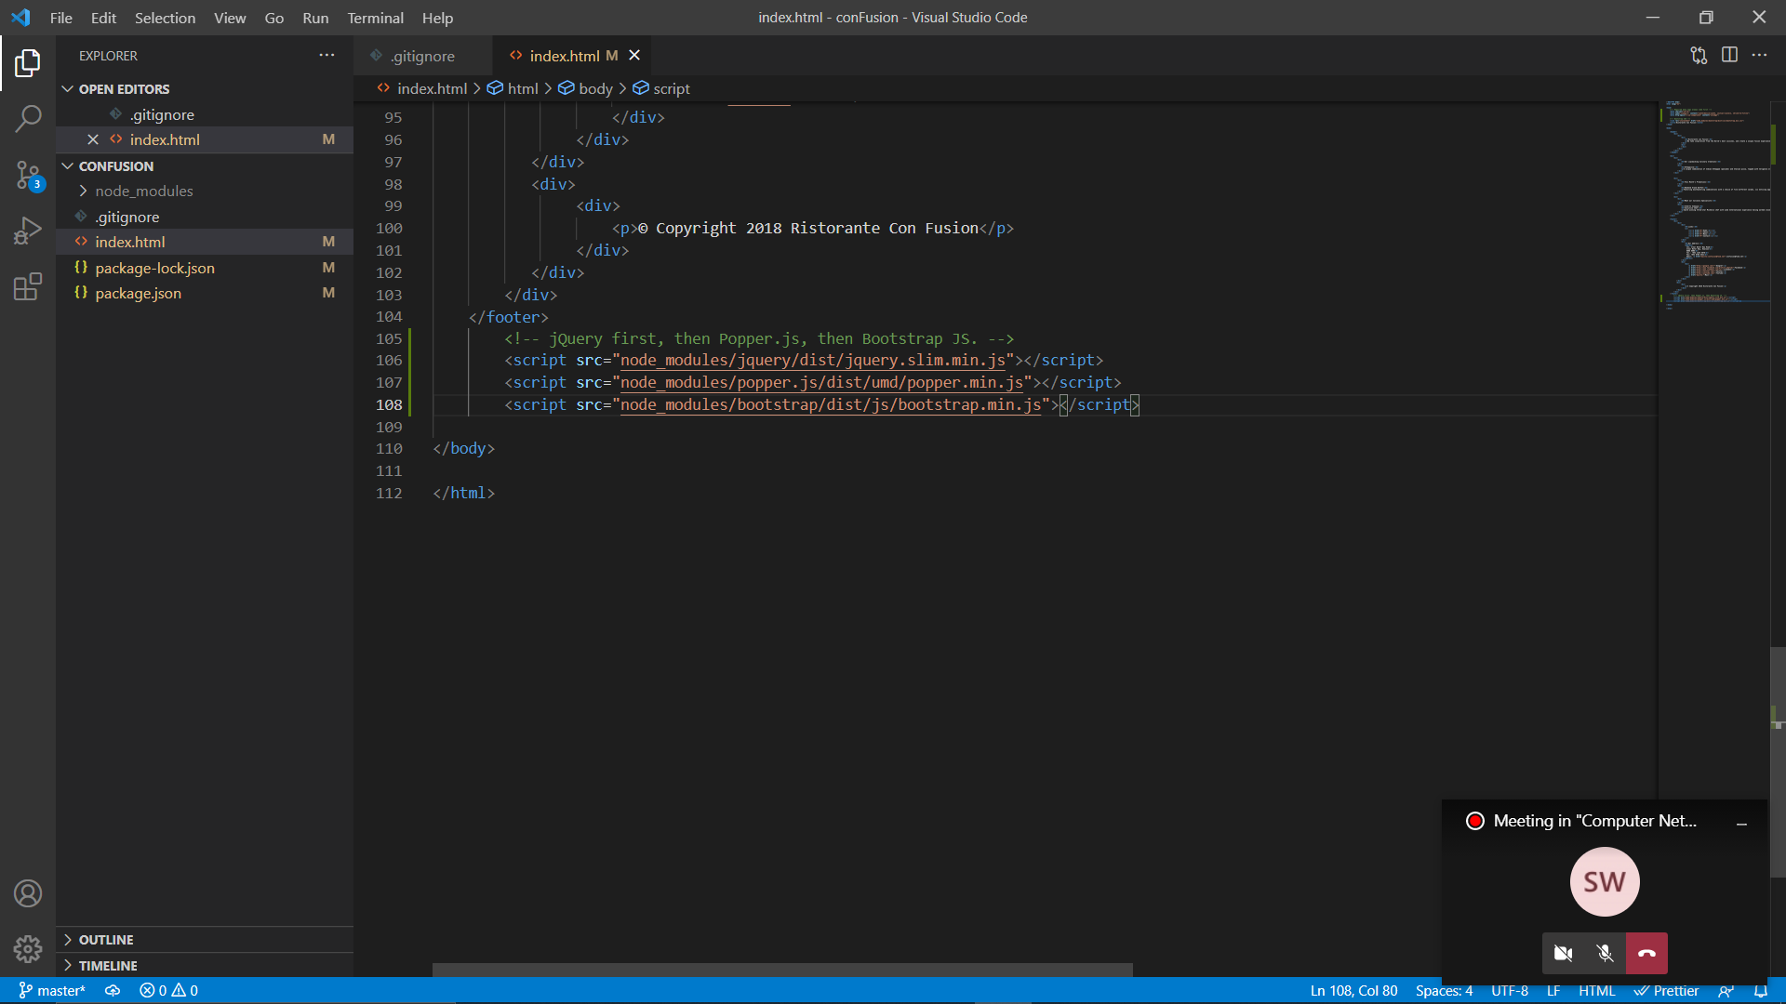

1. After that do a git commit

**git add .**

**git commit –m …**